UNIVERSITY INSTITUTE OF COMPUTING

PROJECT REPORT ON
FILE MANAGER

Program Name: BCA
Subject Name/Code: Java Programming(23CAT-351)

Submitted by: Submitted to:
Name: Kanishka Name: Mr.Rishabh UID: 22BCA10355 Designation: Professor Section: BCA – 5 “A”

ABSTRACT

This report explains how a File Manager application was created using the Java programming language. The main goal of this project was to build a simple tool that can perform basic file operations like copying files, deleting files, listing all files in a folder, and reading or writing data to files.
A special focus was given to exception handling, which means the program is designed to manage errors (like missing files or read/write problems) without crashing. This makes the application more reliable and user-friendly.
Overall, this project helps students learn how to work with files in Java, understand how computers manage data through the file system, and learn how to handle unexpected issues that may happen when working with files.

Introduction
Modern applications often require file system access for tasks like configuration management, data storage, and backup. This File Manager project introduces students to core file handling operations. It serves as a basic command-line utility that performs essential file tasks, including copying content between files, deleting files, listing files within directories, and reading/writing text data. Java provides the java.io and java.nio packages for file handling, making it a suitable language for implementing this utility.
This project aims to build familiarity with these Java libraries, alongside developing skills in structured exception handling using try-catch-finally blocks. The application is console-based and focuses on simplicity and clarity of operations.

Project Overview
The File Manager is designed as a utility that can perform:
 Copying Files: From a source path to a destination.
 Deleting Files: From the file system after user confirmation.
 Listing Files: All files and subdirectories within a selected directory.
 Reading/Writing: Textual content from and to files.

Features
The application will provide the following features:
- List Directory Contents: View files and subdirectories from a given path.
- Copy File: Copies file contents from one file to another specified by the user.
- Delete File: Deletes a specified file from the disk with user confirmation.
- Read File: Displays content of a selected file.
- Write to File: Writes user-entered content into a file, with overwrite or append options.
- Error Reporting: Clear error messages if a file is missing, locked, or corrupted.
- Cross-platform Console Usage: Runs on any system with a Java environment.

Architecture
The application uses a procedural programming approach. It operates via a command-line interface and follows modular design for each file operation.

Structure:
  - FileManagerMain: Entry point, presents menu and routes user input.
  - FileHandler: Contains static methods for copy, delete, list, read, and write operation
  - ExceptionHandler: Custom utility for detailed exception logging.

Modules:
  - Input Handler – Reads user commands.
  - File Operations Module – Executes file actions.
  - Console Logger – Prints information to the user.
  - Exception Manager – Catches, classifies, and responds to runtime exceptions.

Implementation Details
The application uses:
  - Java File Class: To interact with files and directories.
  - BufferedReader/BufferedWriter: For efficient text I/O operations.
  - FileInputStream/FileOutputStream: For binary data handling during copying.
  - try-catch blocks: To catch exceptions such as FileNotFoundException, IOException.
  - Scanner: To accept user input.
  - Command-line Interface: For user interaction.

2.Code Snippets
Since the purpose of this report is to describe the application without including code, this section will focus on describing what the code would do, rather than showing the code itself. Copy File Functionality:
Prompts for source and destination file paths.
Uses FileInputStream and FileOutputStream. Catches exceptions for invalid paths or write permissions.

Delete File:
Uses File.delete() after checking file existence. Confirms with user before deletion.

List Files:
Accepts directory path.
Uses File.listFiles() to retrieve all files and folders.

Read File:
Uses BufferedReader to read content line-by-line.

Displays content to the console.

Write to File:
Prompts for content and whether to overwrite or append. Uses BufferedWriter for writing.

Error Handling:
Handles:
File not found Read/write access denied
Invalid input
Null pointer exceptions

3.Future Enhancements
.The application can be enhanced with the following features: GUI Integration: Adding a simple Swing/JavaFX interface. Drag-and-Drop File Operations.
Search Capability: File name or type-based search in directories.
Batch Operations: Handling multiple files at once.
File Preview: Viewing basic metadata (size, last modified).
Advanced Exception Logging: Export logs to a file

2.Conclusion
The File Manager project helps in better understanding how to work with files in Java, including how to read, write, copy, and delete files. It also teaches how to handle errors properly so the program doesn't crash when something goes wrong, like when a file is missing.
The project uses a simple and organized structure, which makes it easy to understand, use, and improve in the future. This basic version can be extended later to include more advanced features like a graphical user interface (GUI) or tools for working with files over a network.

SUMMARY
This report explains the design and development of a Java-based File Manager application. The application is built using a modular approach, separating file operations, user input handling, and process control for better organization and understanding. The File Manager supports basic file handling tasks such as listing files in a directory, copying files, deleting files, and reading/writing file content.
The program also includes strong exception handling features to manage common errors such as "File Not Found", "Access Denied", or input/output issues. This helps improve the stability and reliability of the application. The report further discusses how the application works step-by-step and explores future improvements like adding a graphical user interface (GUI) or remote file management capabilities.
Input:
The input section of the File Manager application is kept simple and user-friendly. Users are asked to provide the following information based on the operation they want to perform:

Operation Choice
The user selects what they want to do — like list files, copy a file, delete a file, or read/write content.
This is usually selected from a displayed menu.

File/Directory Path
Depending on the operation, the user must enter the file name or folder path. For example, to copy a file, both the source and destination paths are needed.

Content (for writing to a file)
If the user wants to write to a file, they need to enter the text that should be saved in the file.

Action Trigger (Menu Option)
After entering the required inputs, the user selects the menu option to start the process. Input validation ensures that:
File paths are not empty or invalid Required fields are not skipped

Example Input:
Operation: Copy File
Source Path: C:\Users\Lakshmi\Documents\file1.txt

Destination Path: D:\Backup\file1.txt
These inputs are passed to the file handling logic where appropriate Java methods are used to perform the task.

Process:
The file handling process is broken down into several key steps:

Input Validation
The system checks if the provided file path is correct, the file exists, and no fields are missing.

Operation Execution
Based on the selected task (copy, delete, list, read/write), the system executes the corresponding Java file I/O method.
Example: Files.copy() for copying, Files.delete() for deleting.

Reading or Writing
If reading a file, the content is displayed to the user.
If writing, the new content is written into the file using FileWriter or
BufferedWriter.

Listing Files
If the user chooses to list files, the system uses the File class to retrieve and display all files in the selected directory.

Output Display
Once the action is complete, a success message is shown: "File copied successfully."
"File deleted successfully." "Directory contents listed below:"

Error Handling
If there’s a problem (file not found, access denied, etc.), a clear error message is displayed, such as:
"Error: File not found."
"Unable to write to file. Check permissions."
The program continues to run and allows users to try again.

o

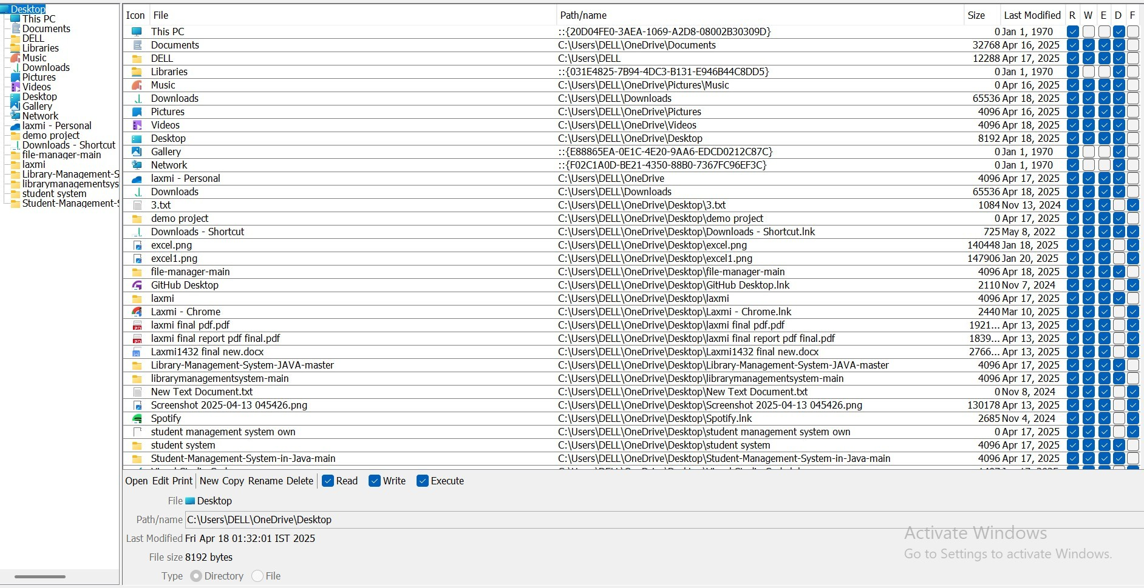
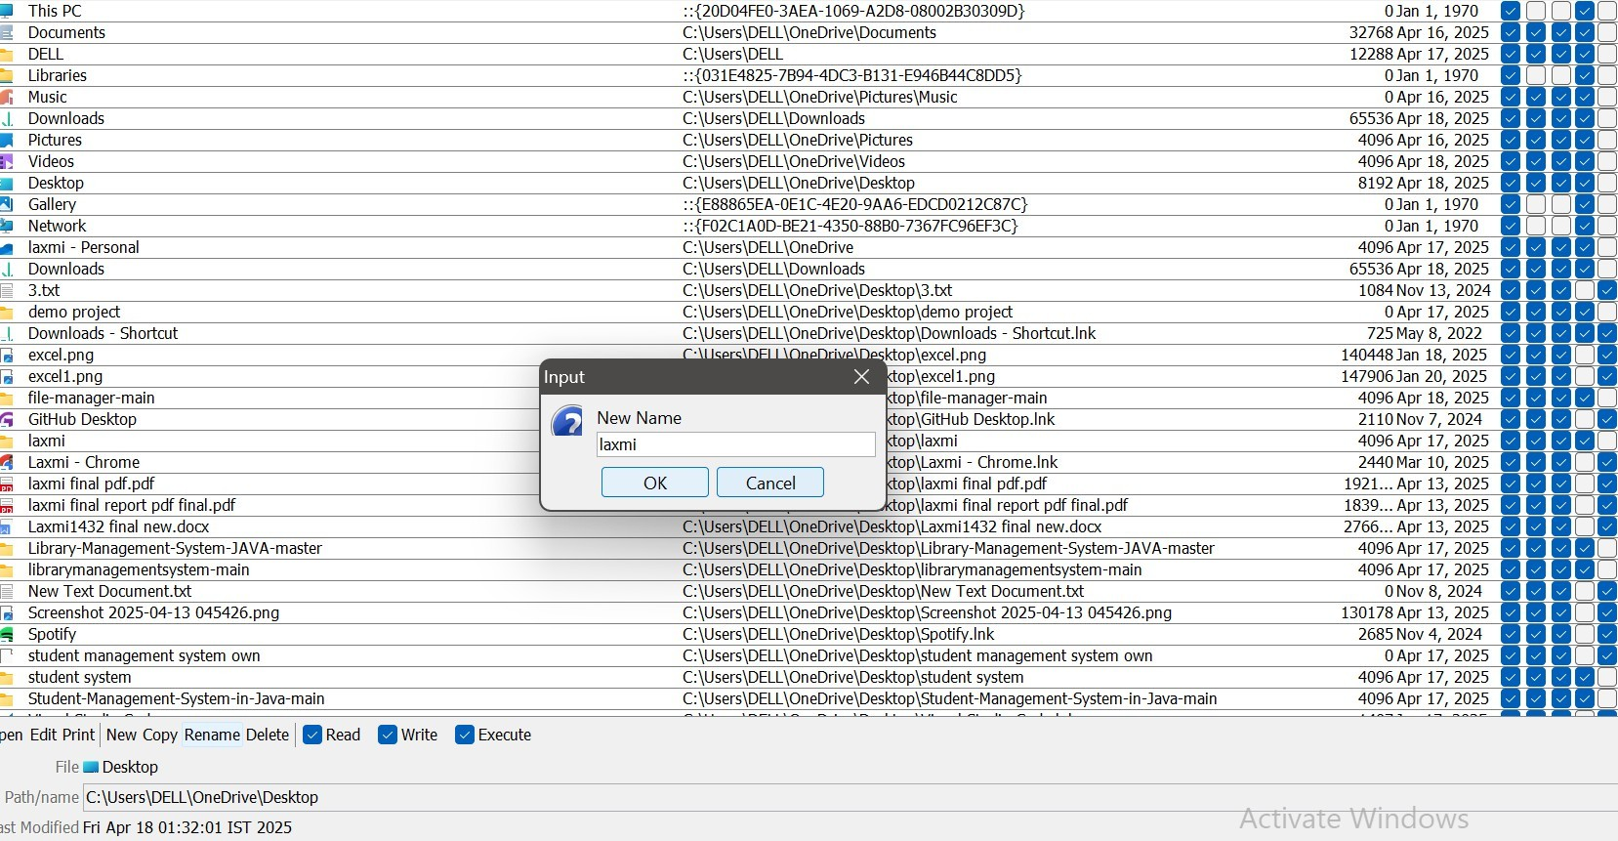
Output:

